1.Draw a labeled diagram of a Cat6 Ethernet cable, showing the color order of wires in the T568B standard and labeling the RJ-45 connector pins.
->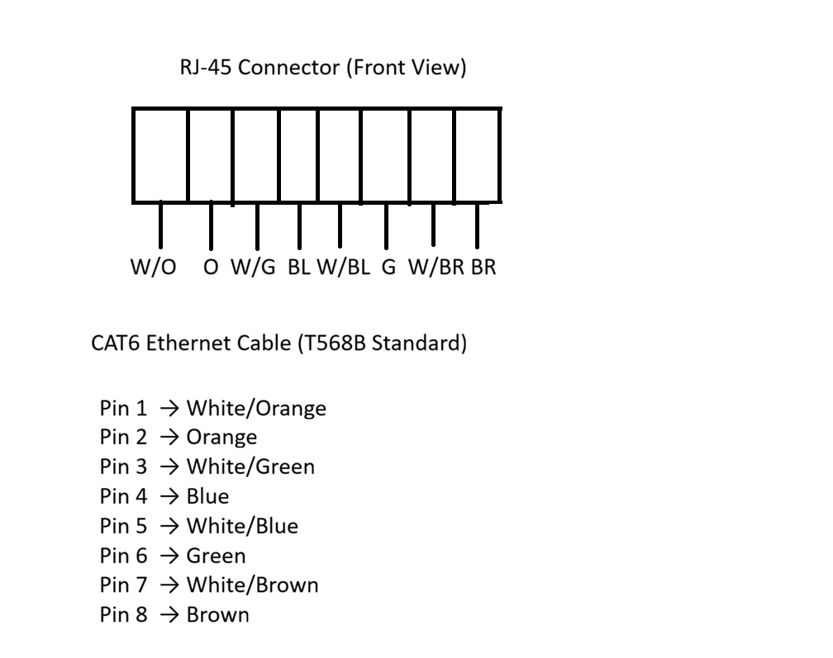2.List three types of network cables (such as Cat5e, Cat6, and fiber optic) and for each, mention one real-world app or device (like a WiFi router, Zomato POS terminal, or IPL streaming server) where it would be used, explaining why.
->
Network Cable | Real-world App/Device | Reason
Cat5e Cable | WiFi Router | Cat5e cable is used to connect the WiFi router to the modem. It provides a stable internet connection for home or office use.
Cat6 Cable | Zomato POS Terminal | Cat6 cable is used in restaurants to connect the POS terminal to the network. It offers faster speed and reliable data transfer for billing and online orders.
Fiber Optic Cable | IPL Streaming Server (JioHotstar) | Fiber optic cable is used in data centers because it supports very high-speed data transfer and can stream live IPL matches to millions of users without much delay.

3.Watch a YouTube video showing how to crimp an RJ-45 connector onto a network cable, then write down the step-by-step process in your own words and mention two common mistakes to avoid.
->Steps to Crimp an RJ-45 Connector:

- First, cut the network cable to the required length.
- Remove about 2–3 cm of the outer cover using a cable stripper.
- Untwist the wire pairs and arrange the wires in the correct T568B color order.
- Straighten the wires and cut them evenly.
- Insert all eight wires into the RJ-45 connector carefully until they reach the end.
- Place the connector into the crimping tool and press it firmly.
- Finally, test the cable using a cable tester to make sure it works properly.

Two Common Mistakes to Avoid:
- Wrong wire color order – If the wires are not arranged according to the T568B standard, the cable may not work.
- Wires not fully inserted – If the wires do not reach the end of the RJ-45 connector before crimping, the connection may fail.
Conclusion:
Crimping an RJ-45 connector correctly is important for a reliable network connection. Following the proper steps and avoiding common mistakes helps the cable work properly.
4.Given the following scenario: You are setting up a gaming zone for an IPL screening event and need to connect multiple screens and consoles. Choose the appropriate cable and connector types for high-speed, reliable connections, and explain your choices.
-> For a gaming zone during an IPL screening event, I would use Cat6 Ethernet cables with RJ-45 connectors.

Reason:

- Cat6 cable provides high-speed data transfer and a stable network connection, which is important for online gaming and live IPL streaming without lag.
- RJ-45 connector is the standard connector used with Cat6 cables. It connects devices like computers, gaming consoles, switches, and routers easily.
- If the screens are placed far away from the network room, I would use Fiber Optic cable because it supports very high speed over long distances with very little signal loss.

Conclusion:
I would choose Cat6 cable with RJ-45 connectors for connecting gaming consoles and screens because they provide fast and reliable performance. For longer distances, Fiber Optic cable is the best option to ensure smooth IPL streaming and gaming.
5.Find and share a photo (from your home, college, or online) of any network cable or connector in use (such as behind a WiFi router or at a café's POS counter), and describe what type it is and what devices it connects.<br><br><em><strong>Hint:</strong> Look for blue or yellow cables with clear plastic ends (RJ-45) or thin round cables for fiber optics.</em>
->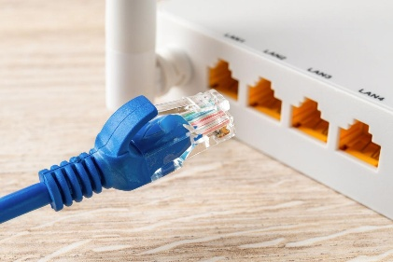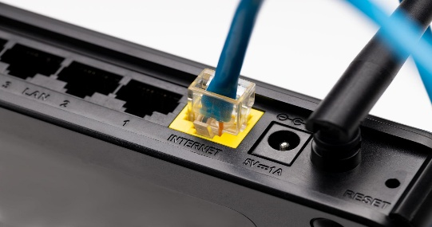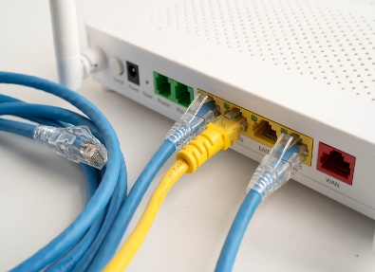
Photo: Cat6 Ethernet cable with an RJ-45 connector connected to a WiFi router.
Description:
The cable shown in the photo is a Cat6 Ethernet cable. It has an RJ-45 connector, which is the standard connector used for Ethernet networking.
This cable connects the WiFi router to the modem or network switch. It provides a fast and stable internet connection, which is better than using a wireless connection for many devices.
Devices Connected:

- WiFi Router
- Modem / Network Switch
Conclusion:The Cat6 cable with an RJ-45 connector is commonly used in homes, colleges, and offices because it offers high-speed, reliable, and stable network connectivity.

